**Step 1:** Login tohttps://studio.azureml.net. If you’ve signed into Machine Learning Studio before, click Sign In. Otherwise, click Sign up here and choose between free and paid options.

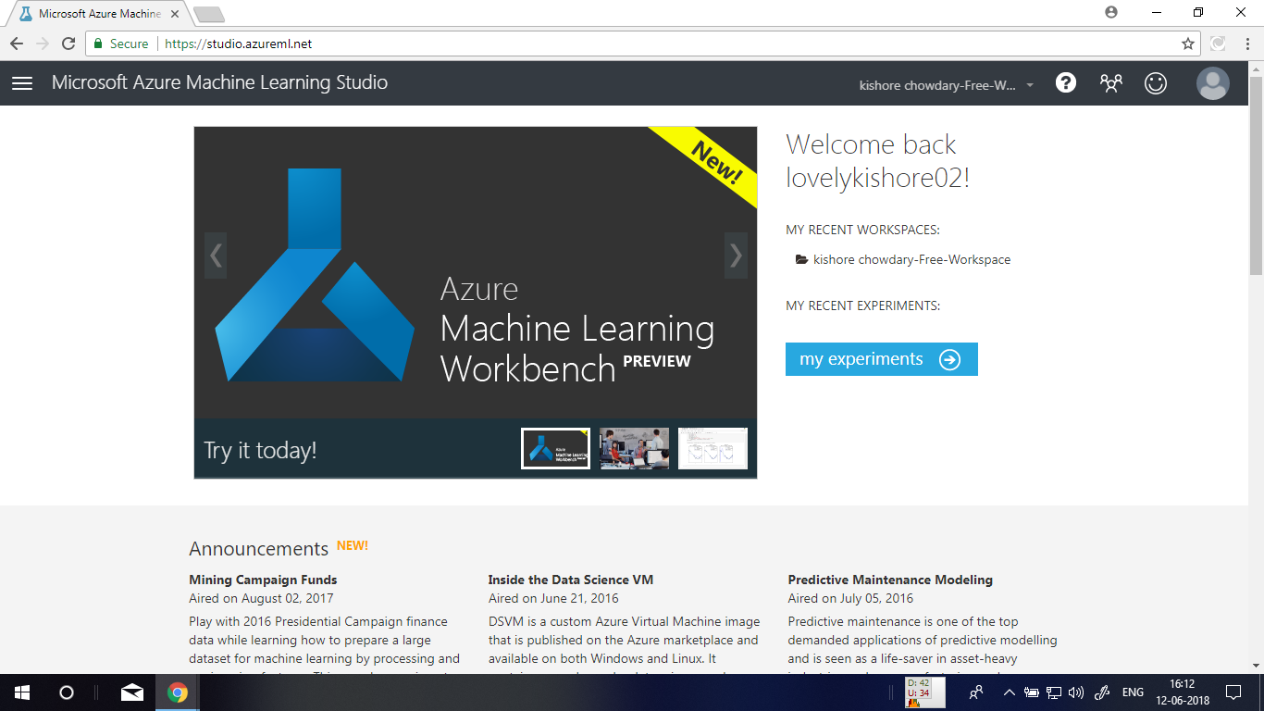

**Step 2:** Create a new experiment by clicking **+NEW** at the bottom of the Machine Learning Studio window, select **EXPERIMENT**, and then select **Blank Experiment**

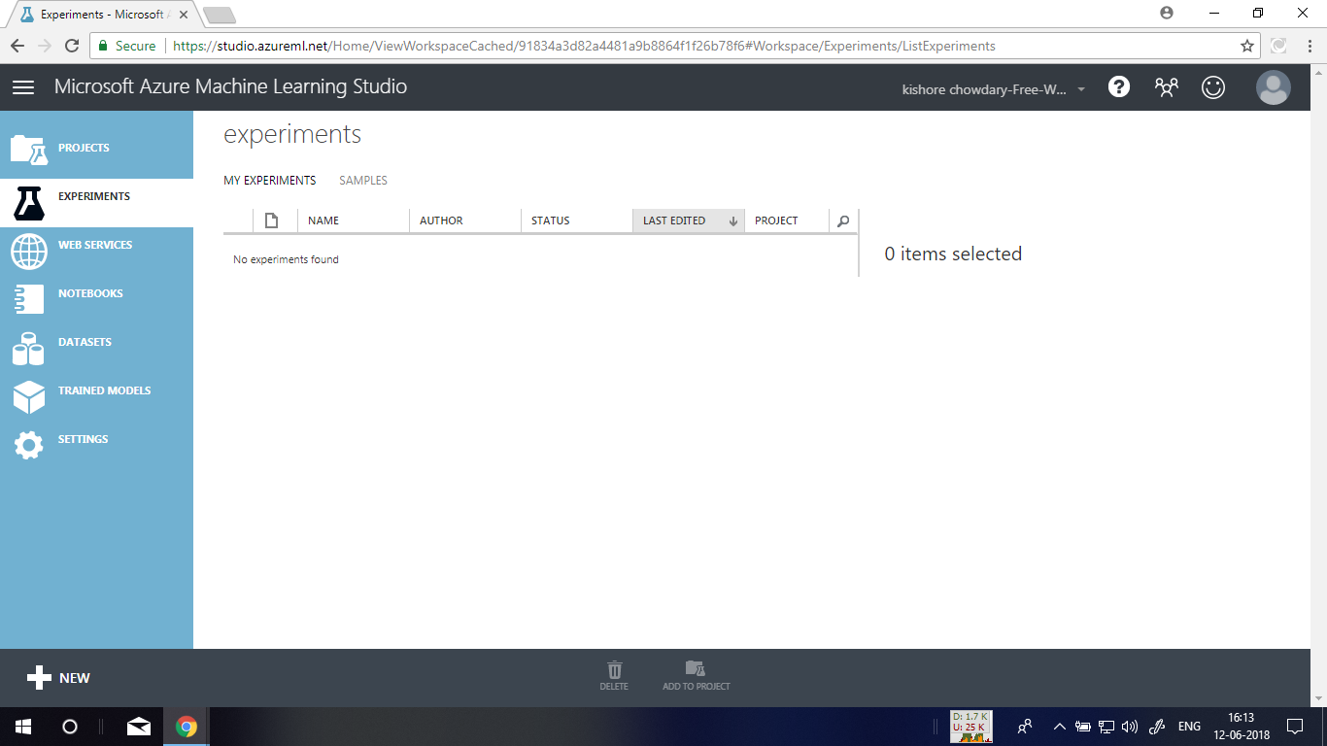

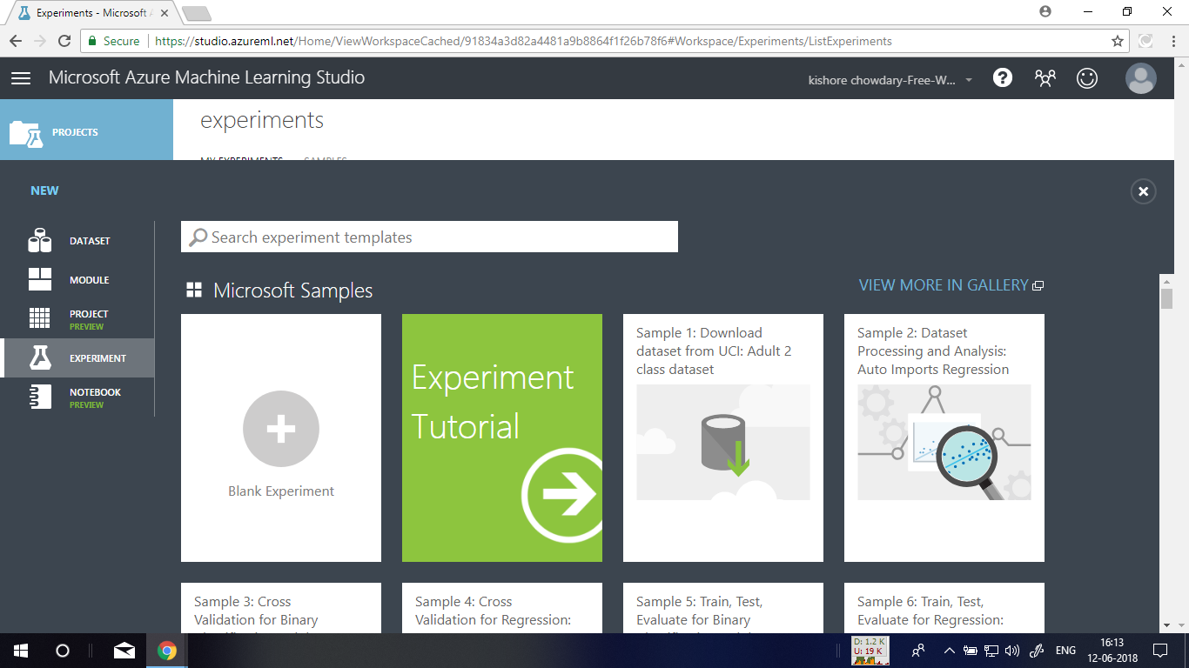

**Step 3: T**he experiment is given a default name that you can see at the top of the canvas. Select this text and rename it to something meaningful, for example, **Automobile price prediction**. The name doesn't need to be unique.

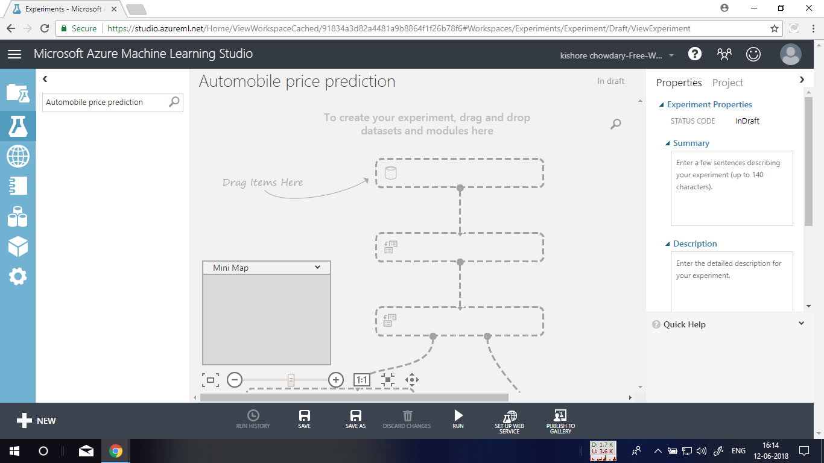

**Step 4:** To the left of the experiment canvas is a palette of datasets and modules. Type **automobile** in the Search box at the top of this palette to find the dataset labeled **Automobile price data (Raw).** Drag this dataset to the experiment canvas.

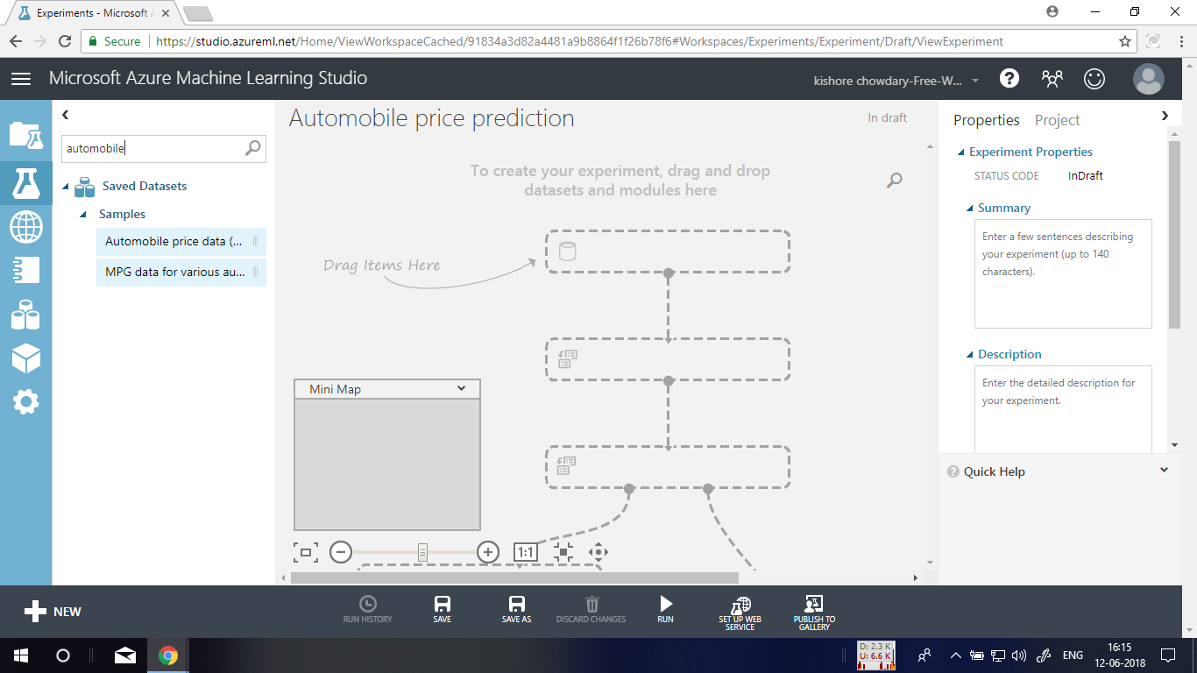

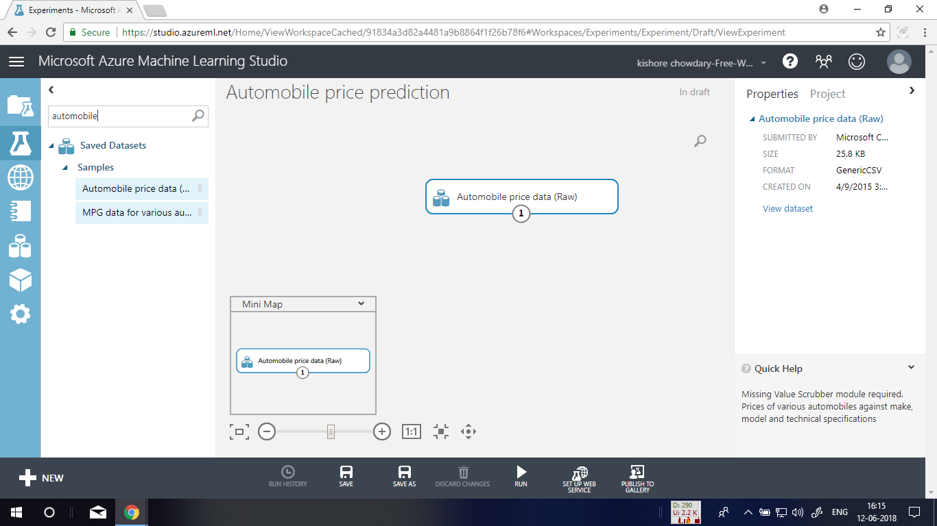

**Step 5:** To see what this data looks like, click the output port at the bottom of the automobile dataset, and then select **Visualize**.

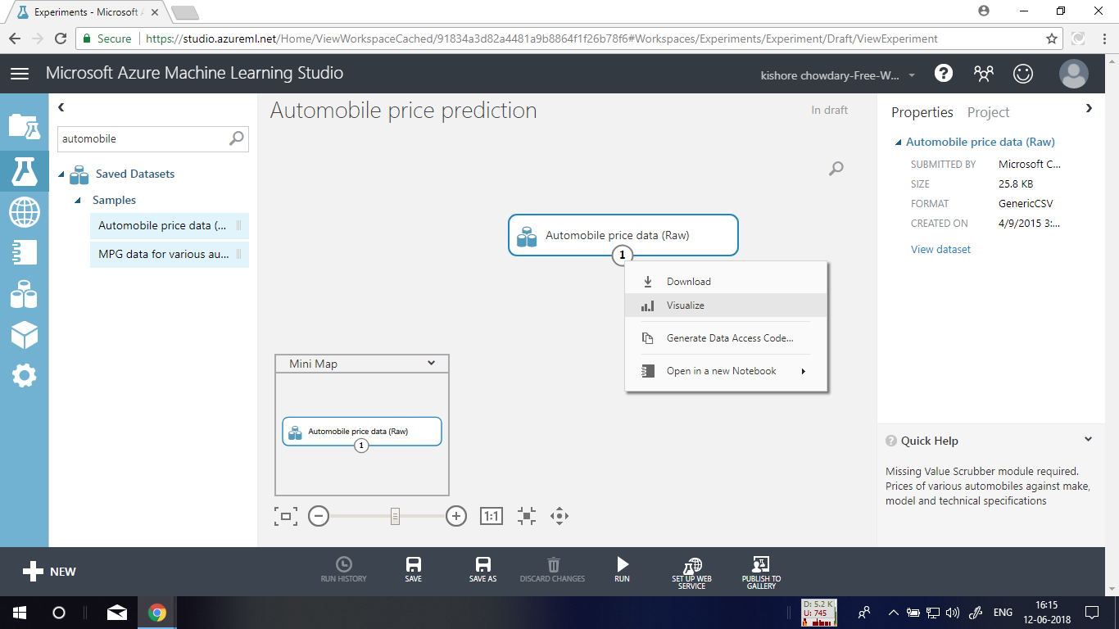

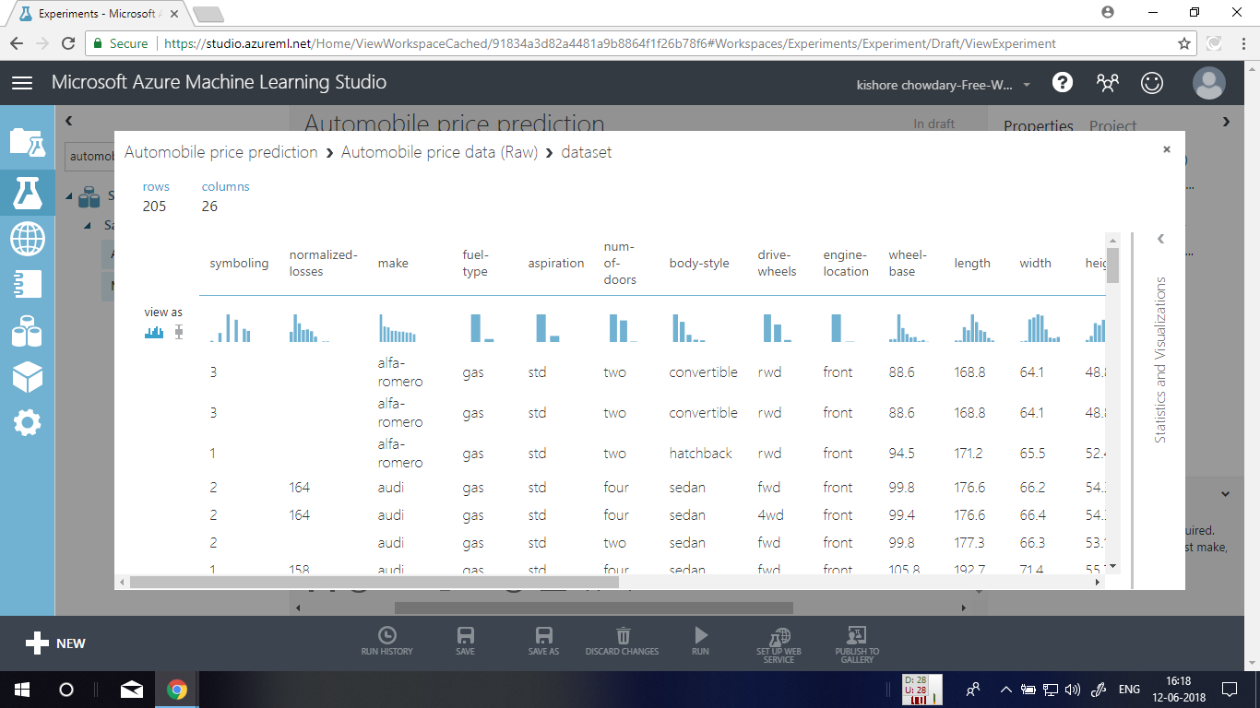

**Step 6:** Type select columns in the Search box at the top of the module palette to find the Select Columns in Dataset module, then drag it to the experiment canvas. This module allows us to select which columns of data we want to include or exclude in the model. **Connect** the output port of the **Automobile price data (Raw)** dataset to the input port of the Select Columns in Dataset module.

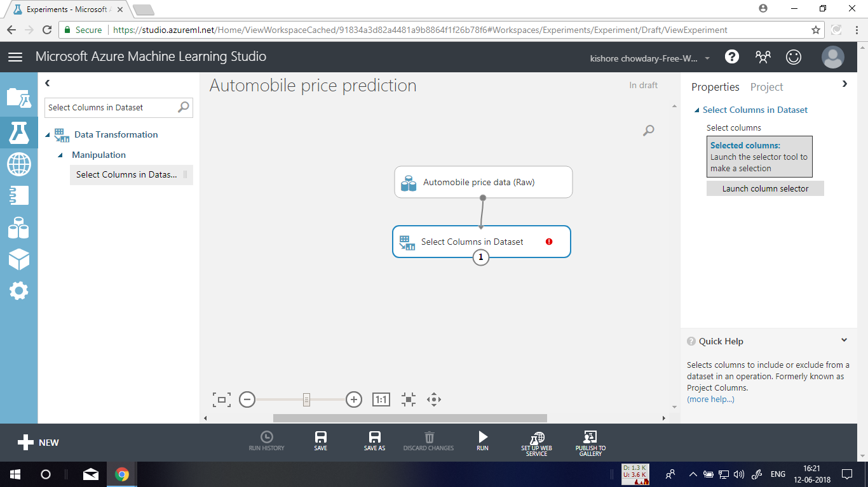

**Step 7:** Click the Select Columns in Dataset module and click Launch column selector in the Properties pane. On the left, click **With rules**. Under **Begin With**, click **All columns**. From the drop-downs, select **Exclude** and **column names**, and then click inside the text box. A list of columns is displayed. Select **normalized-losses**, and it's added to the text box. Click the check mark (OK) button to close the column selector (on the lower-right).

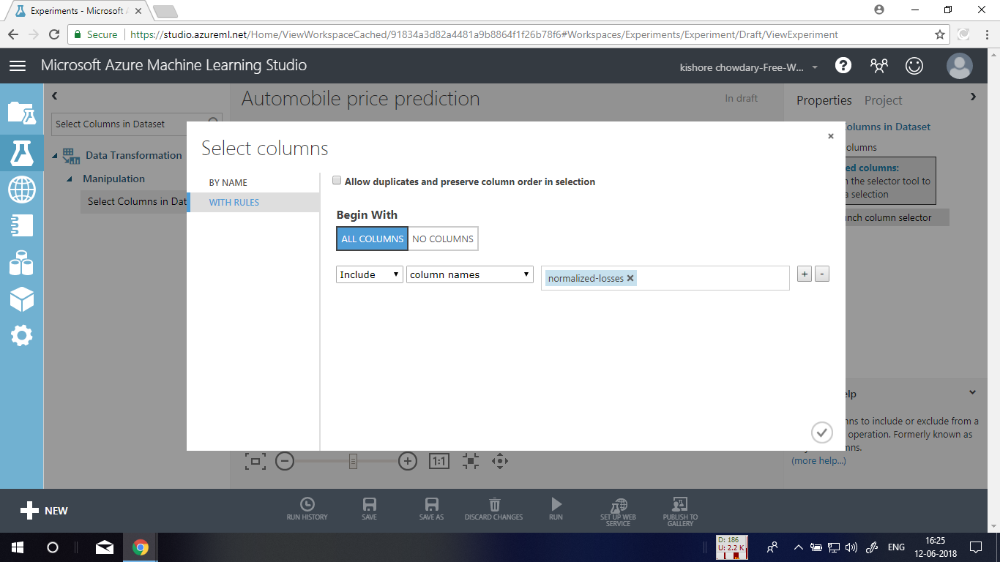

Now the properties pane for **Select** **Columns in Dataset** indicates that it will pass through all columns from the dataset except **normalized-losses**.

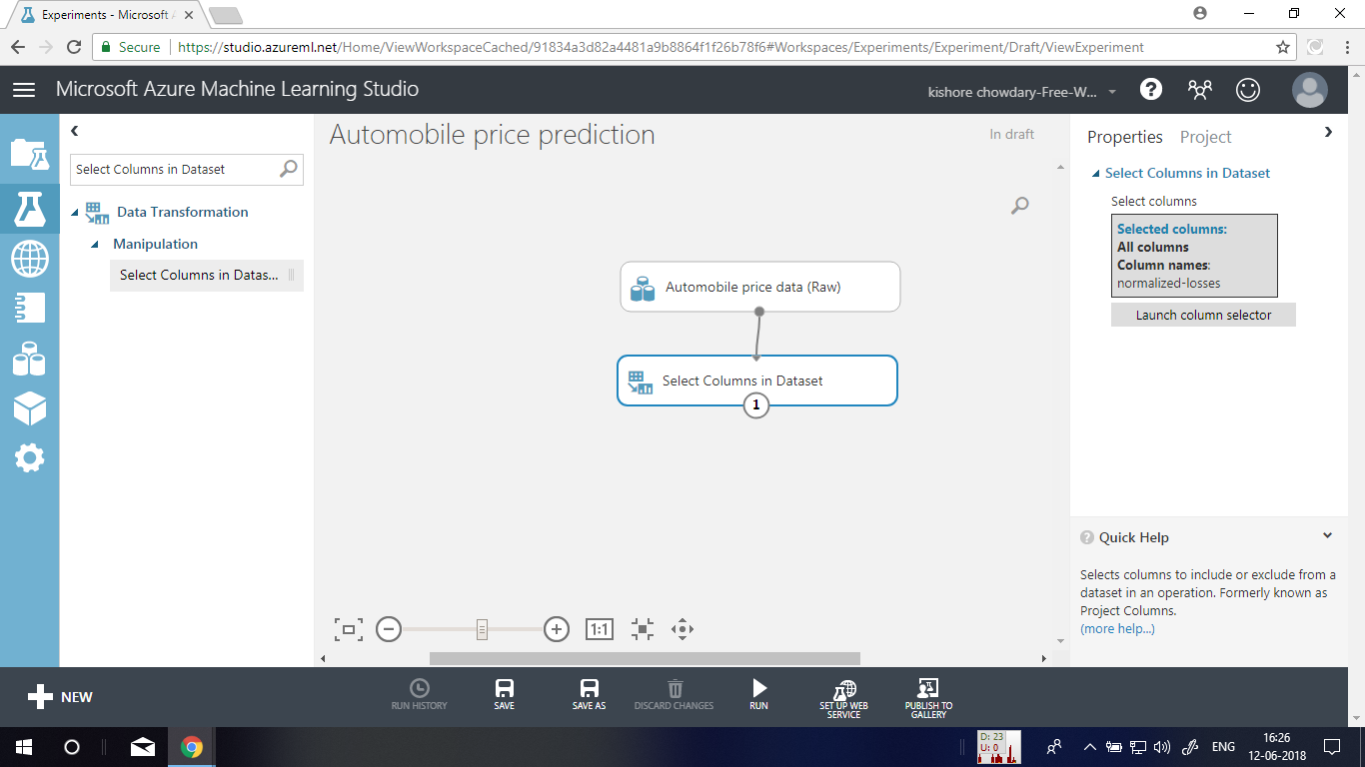

**Step 8:** Drag the **Clean Missing Data** module to the experiment canvas and connect it to the **Select Columns in Dataset** module.

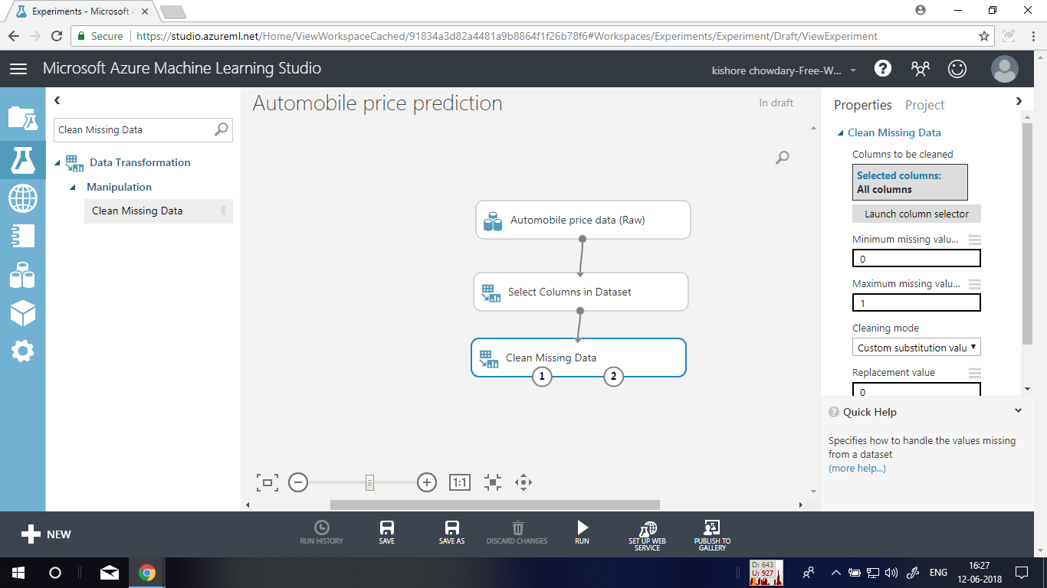

**Step 9:** In the **Properties** pane, select **Remove entire row** under **Cleaning mode**. This directs Clean Missing Data to clean the data by removing rows that have any missing values.

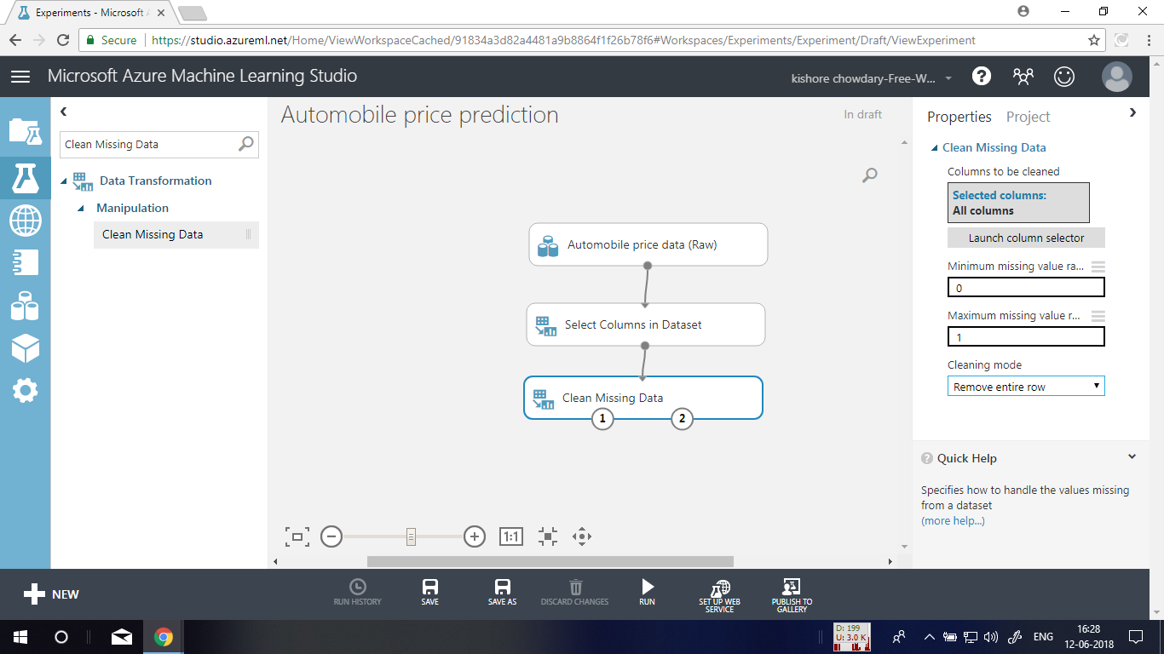

**Step 10:** Drag another **Select Columns in Dataset** module to the experiment canvas. Connect the left output port of the **Clean Missing Data** module to the input of the **Select Columns in Dataset** module.

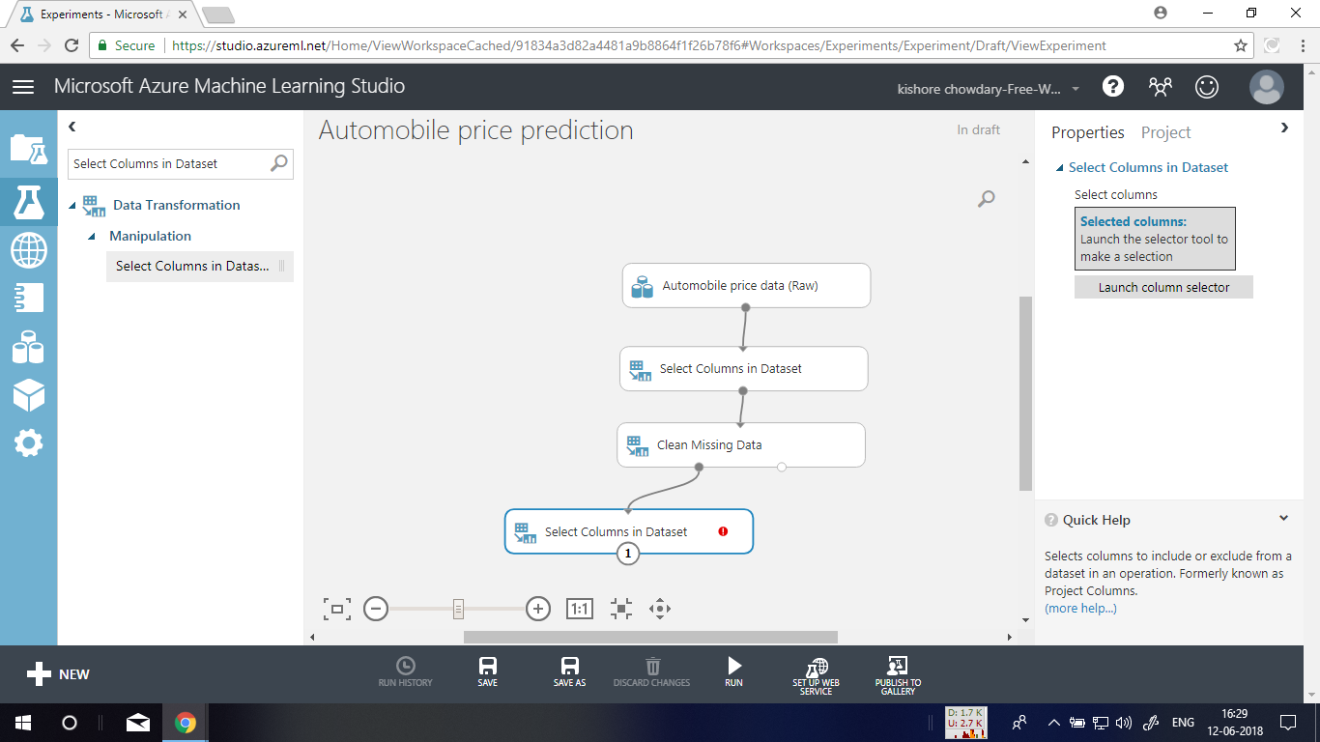

**Step 11:** Double-click the module and type "Select features for prediction." Click **Launch column selector** in the **Properties** pane. Click **With rules**. Under **Begin With**, click **No columns**. In the filter row, select **Include** and **column names** and select our list of column names in the text box. This directs the module to not pass through any columns (features) except the ones that we specify. Click the check mark (OK) button.

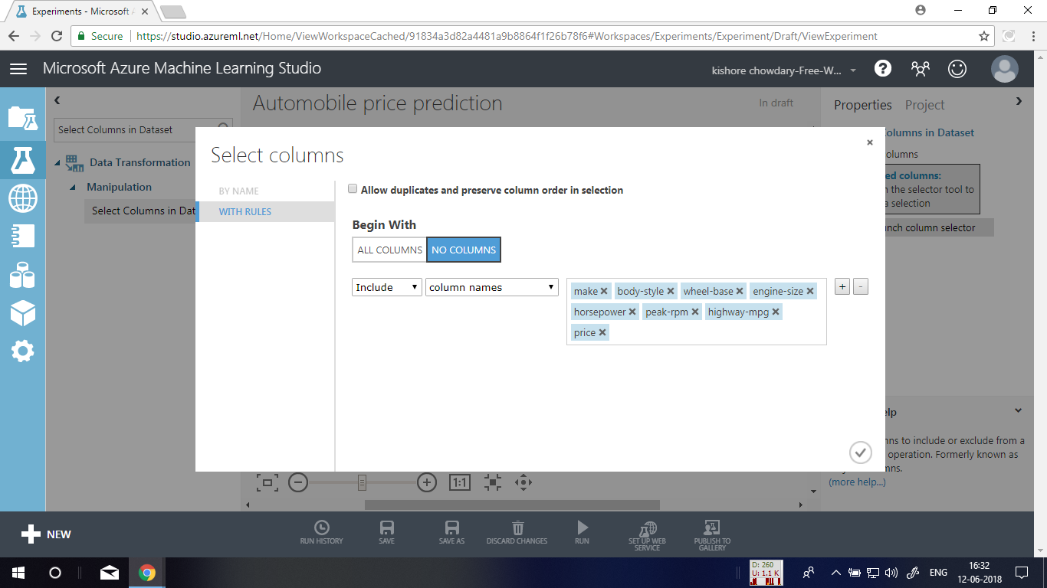

**Step 12:** Select and drag the **Split Data** module to the experiment canvas and connect it to the last **Select Columns in Dataset** module

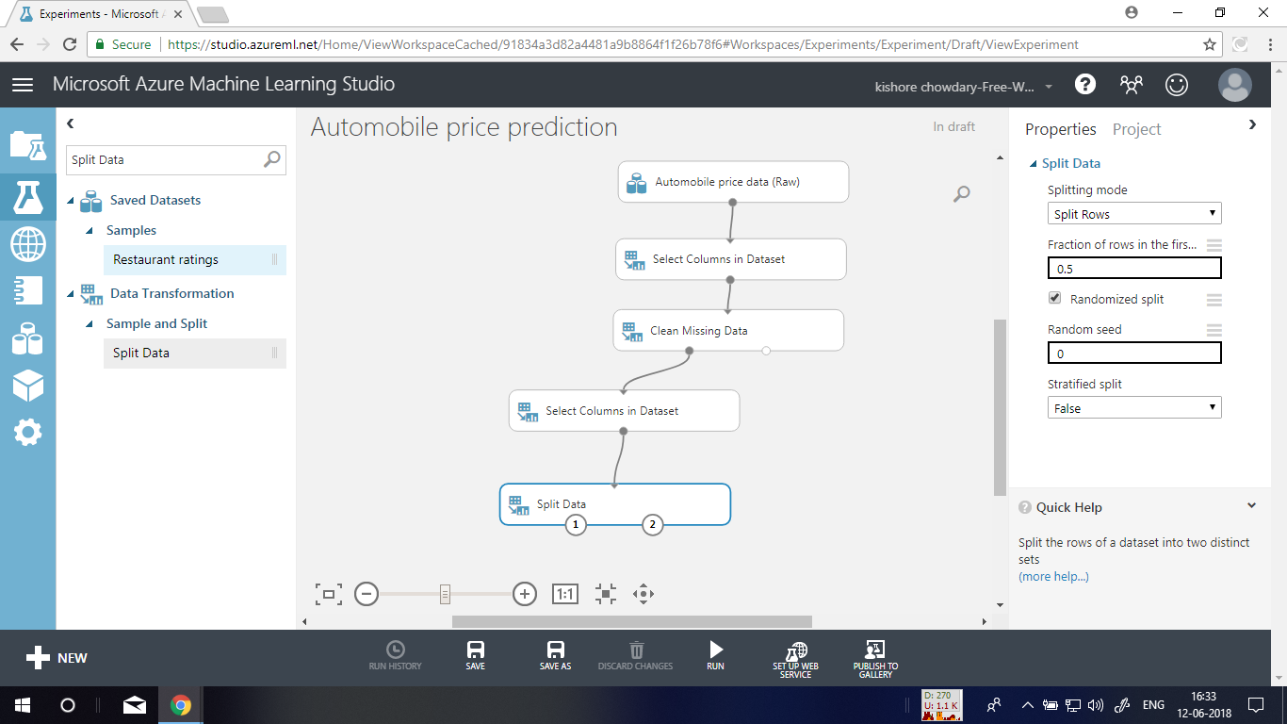

**Step 13:** Click the **Split Data** module to select it. Find the **Fraction of rows in the first output dataset** (in the **Properties** pane to the right of the canvas) and set it to 0.75. This way, we'll use 75 percent of the data to train the model, and hold back 25 percent for testing (later, you can experiment with using different percentages).

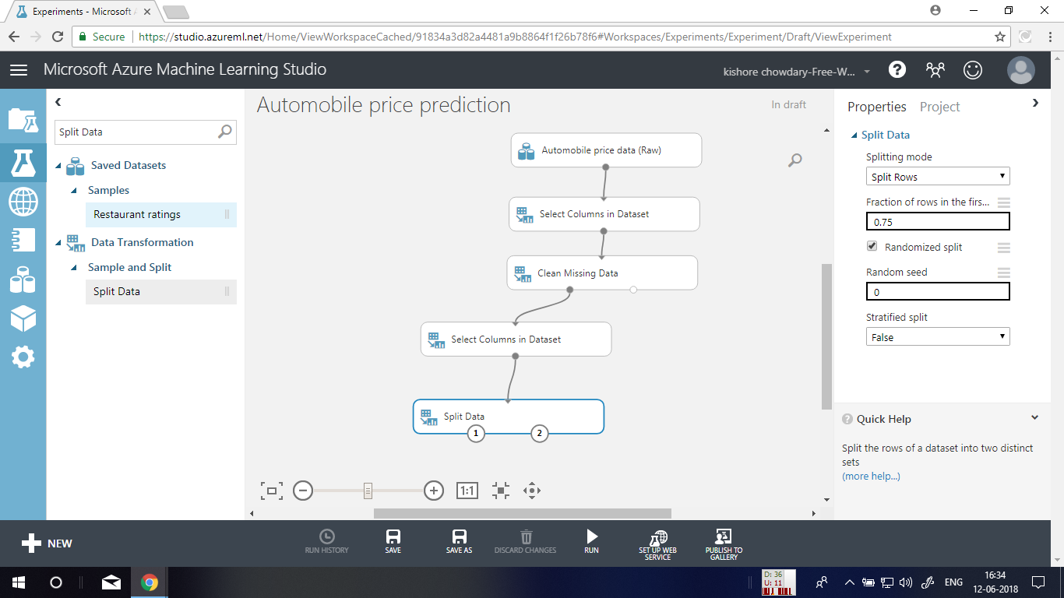

**Step 14:** Run the experiment. When the experiment is run, the **Select Columns in Dataset** and **Split Data** modules pass column definitions to the modules we'll be adding next.

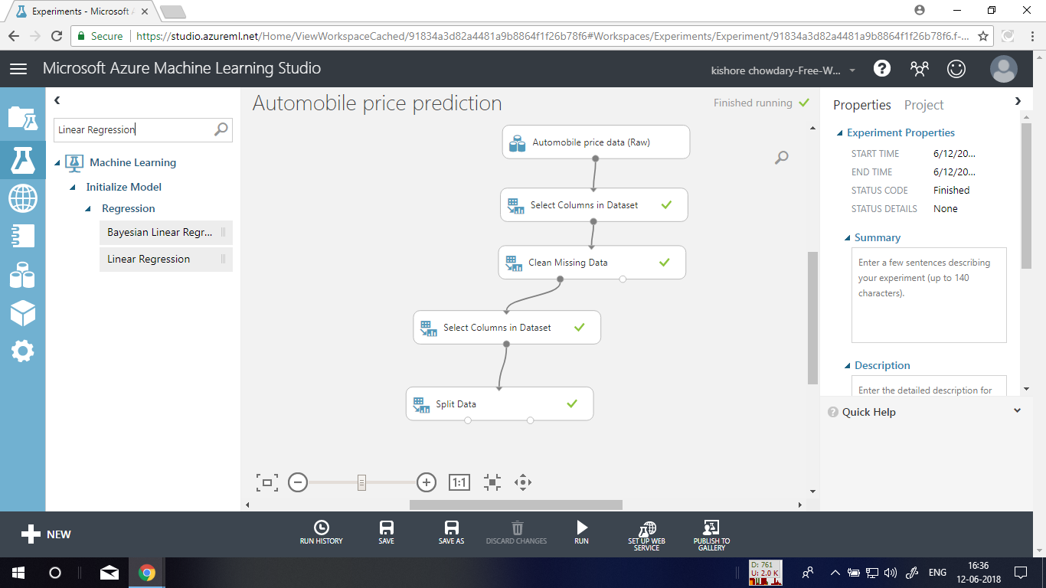

**Step 15:** Select the **Linear Regression** module under the Regression category and drag it to the experiment canvas.

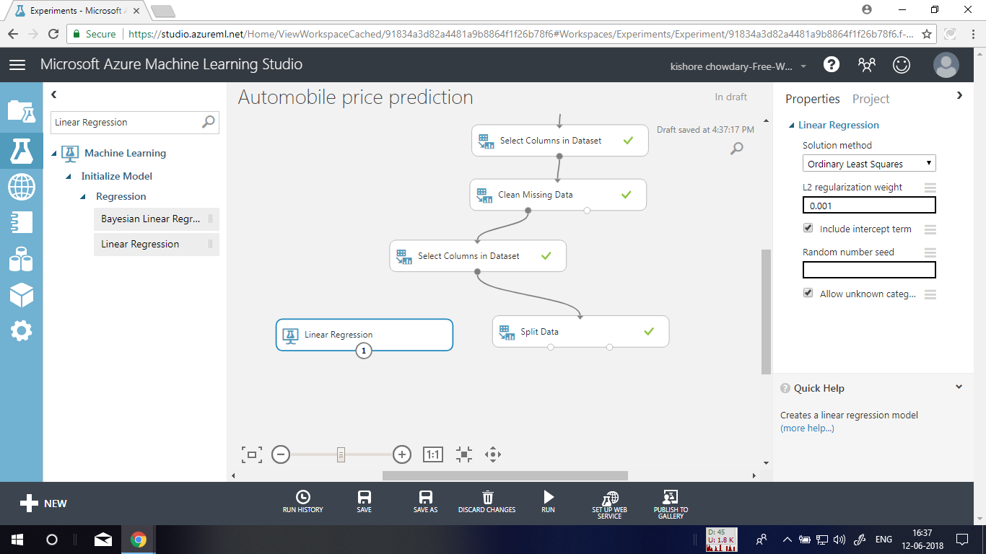

**Step 16:** Find and drag the **Train Model** module to the experiment canvas. Connect the output of the **Linear Regression** module to the left input of the **Train Model** module, and connect the training data output (left port) of the **Split Data** module to the right input of the **Train Model** module

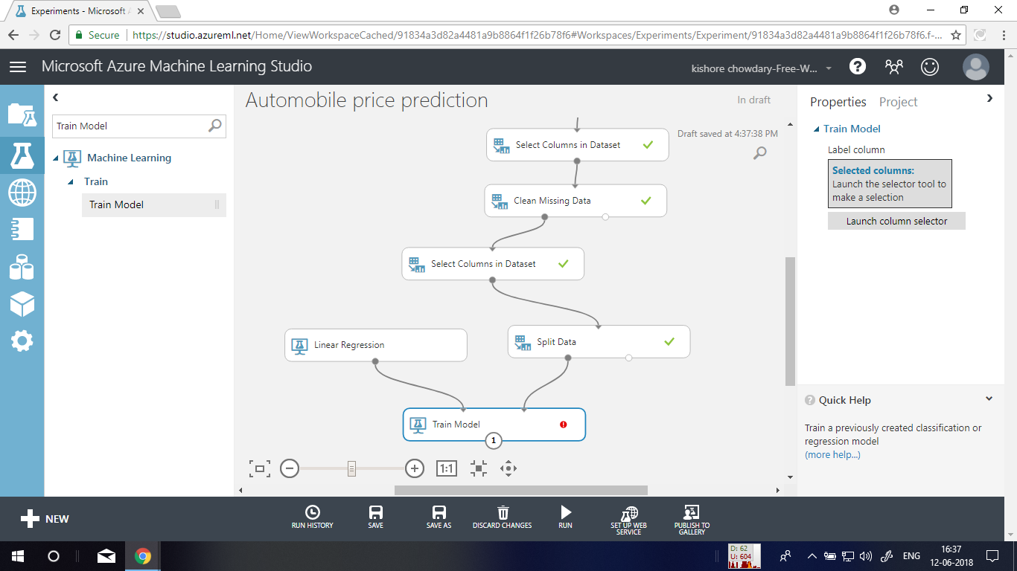

**Step 17:** Click the **Train Model** module, click **Launch column selector** in the **Properties** pane, and then select the **price** column. This is the value that our model is going to predict. You select the **price** column in the column selector by moving it from the **Available columns** list to the **Selected columns** list.

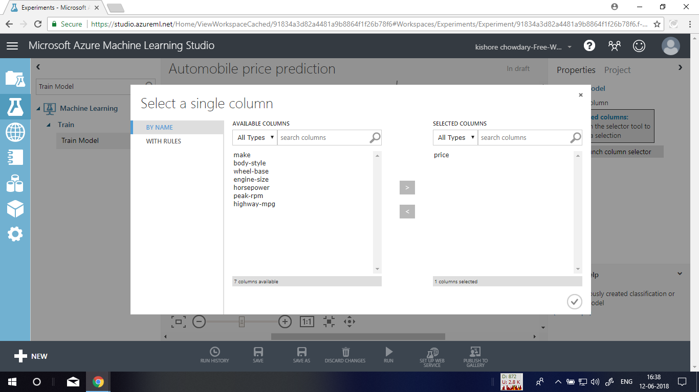

**Step 18: Run** the experiment. We now have a trained regression model that can be used to score new automobile data to make price predictions.

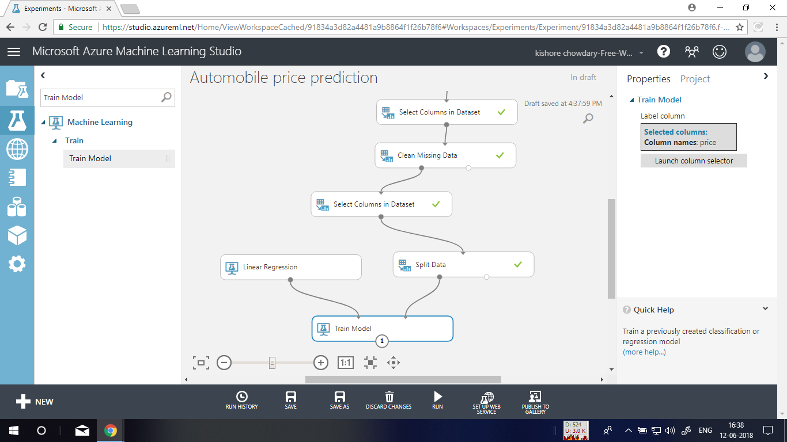

**Step 19:** Now that we've trained the model using 75 percent of our data, we can use it to score the other 25 percent of the data to see how well our model functions. Find and drag the **Score Model** module to the experiment canvas. Connect the output of the **Train Model** module to the left input port of **Score Model**. Connect the test data output (right port) of the **Split Data** module to the right input port of **Score Model**.

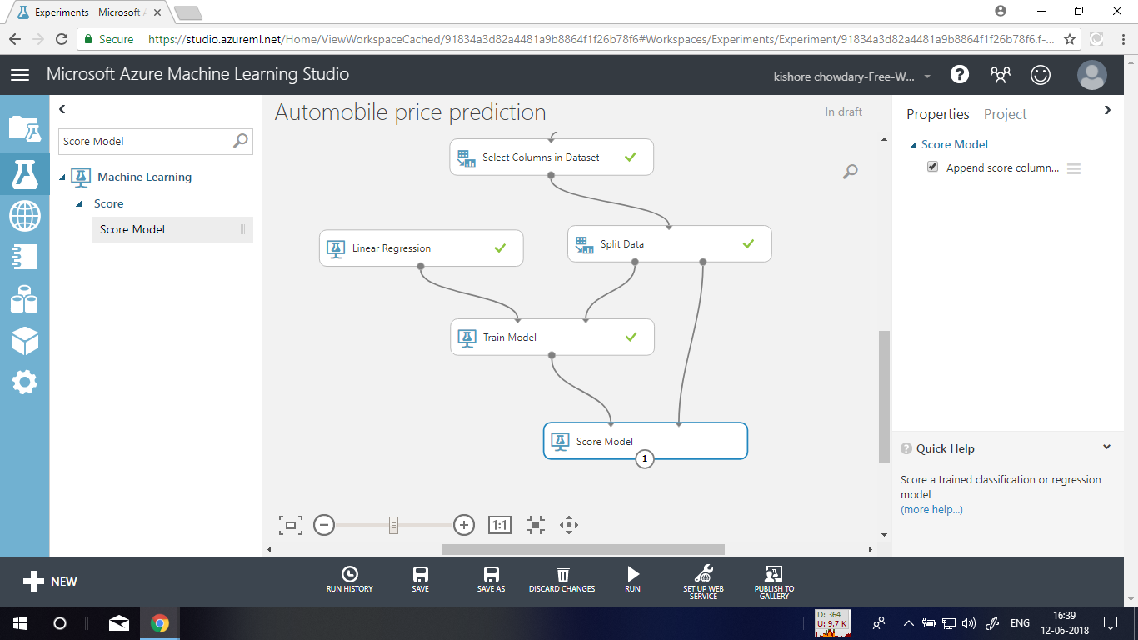

**Step 20:** Run the experiment and view the output from the Score Model module (click the output port of Score Model and select **Visualize**). The output shows the predicted values for price and the known values from the test data.

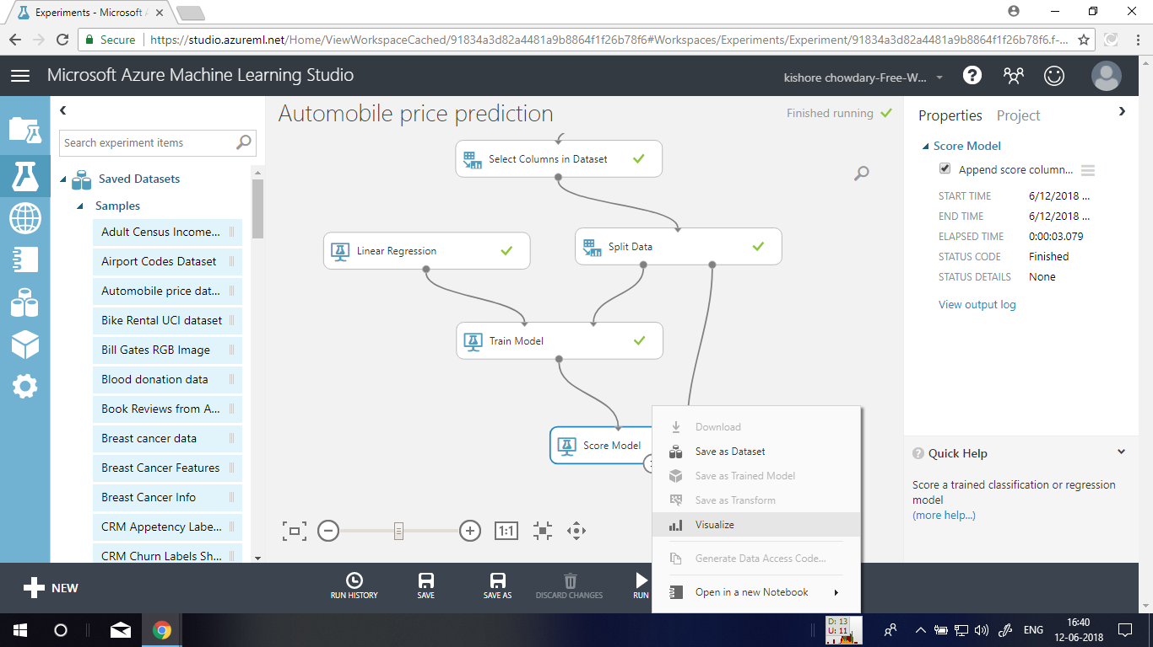

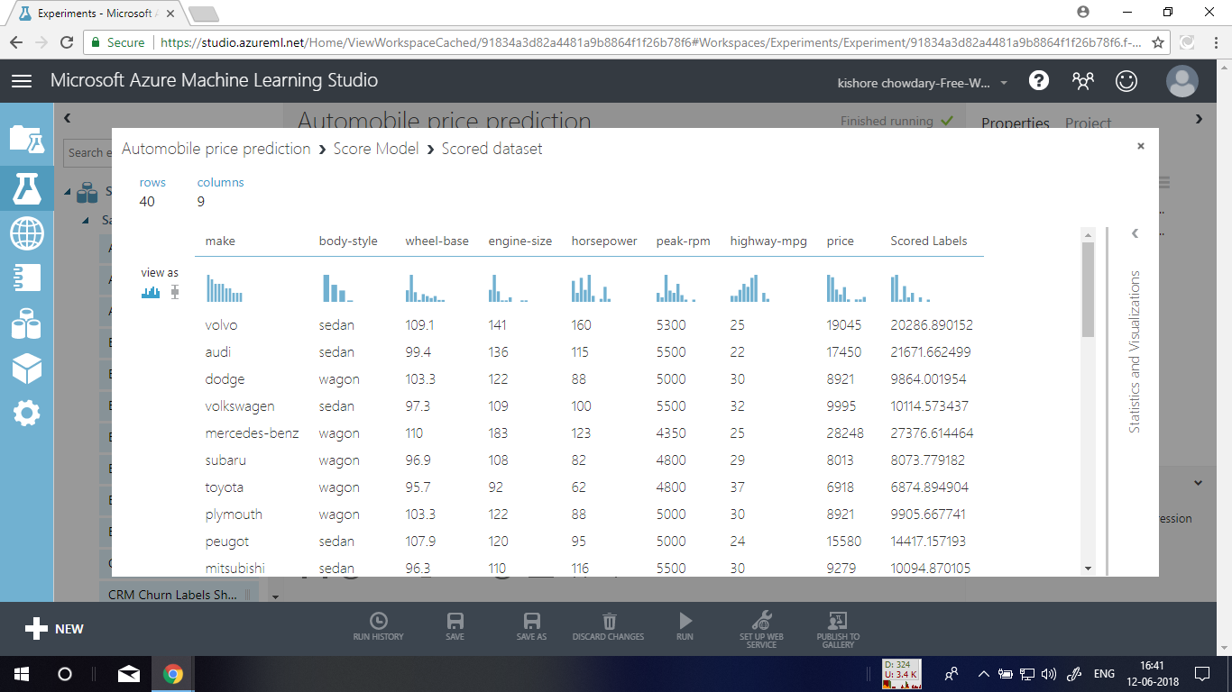

**Step 21:** Finally, we test the quality of the results. Select and drag the **Evaluate Model** module to the experiment canvas, and connect the output of the **Score Model** module to the left input of **Evaluate Model**.

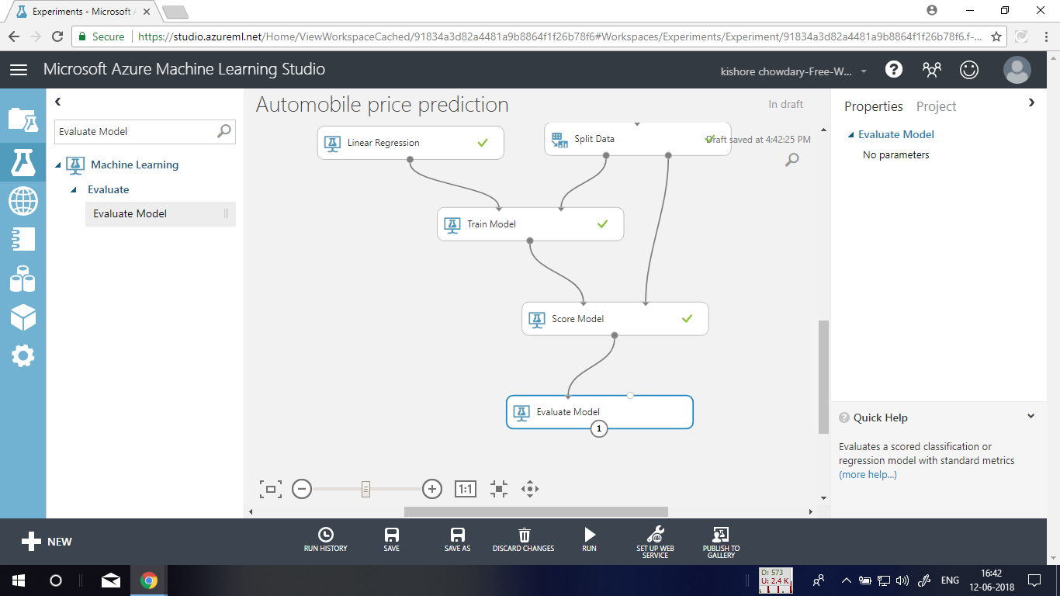

**Step 22:** Run the experiment. To view the output from the Evaluate Model module, click the output port, and then select **Visualize**.

